EXPERIMENT – 7
Implementation of Logistic Regression (LR) Algorithm using Python
AIM
To implement the Logistic Regression algorithm in Python for classification of data samples.
APPARATUS REQUIRED
- Google Colab
- Python 3.x
- NumPy
- Pandas
- Scikit-learn
- Matplotlib
ALGORITHM
- Start the program.
- Import the required Python libraries.
- Load the dataset.
- Separate the input features and target variable.
- Split the dataset into training and testing data.
- Create a Logistic Regression model.
- Train the model using the training data.
- Predict the target values for the test data.
- Evaluate the classification results.
- Display the predicted results.
- Stop the program.

PROGRAM
# Experiment 7: Logistic Regression
# Import required libraries
import pandas as pd
import matplotlib.pyplot as plt

from sklearn.datasets import load_iris
from sklearn.model_selection import train_test_split
from sklearn.linear_model import LogisticRegression
from sklearn.metrics import accuracy_score, confusion_matrix
# Load Iris dataset
iris = load_iris()
X = iris.data
y = iris.target
# Split the dataset into training and testing data
X_train, X_test, y_train, y_test = train_test_split(
X, y, test_size=0.2, random_state=42
)
# Create Logistic Regression model
model = LogisticRegression(max_iter=200)
# Train the model
model.fit(X_train, y_train)
# Predict test data
y_pred = model.predict(X_test)
# Calculate accuracy
accuracy = accuracy_score(y_test, y_pred)

print("Accuracy:", accuracy)
# Display confusion matrix
cm = confusion_matrix(y_test, y_pred)
print("\nConfusion Matrix:")
print(cm)
OUTPUT
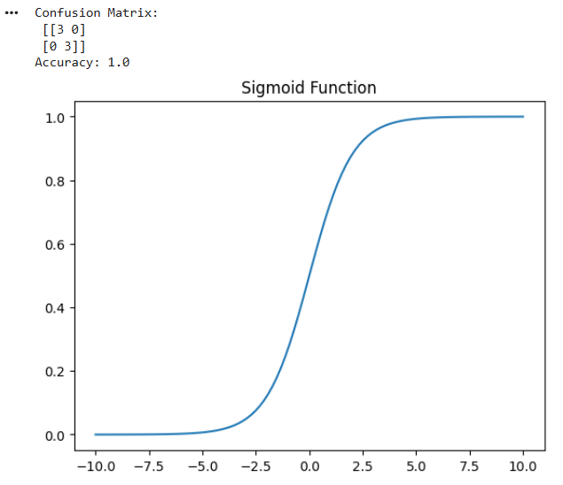
RESULT
Thus, the Logistic Regression algorithm was successfully implemented using Python in Google Colab and the classification results were obtained.

